Project Planning Phase
Project Planning Template (Product Backlog, Sprint Planning, Stories, Story points)

Date | 30 June 2026
Team ID
Project Name | Cab Booking Platform
Maximum Marks | 5 Marks

Product Backlog, Sprint Schedule, and Estimation (4 Marks)
Use the below template to create product backlog and sprint schedule
Sprint | Functional Requirement (Epic) | User Story Number | User Story / Task | Story Points | Priority | Team Members
Sprint-1 | Registration | USN-1 | As a user, I can register using name, email and password. | 2 | High | Kuruba Sai Mahathi
Sprint-1 | Registration | USN-2 | As a user, I receive a successful registration confirmation. | 1 | High | Mahesh Patta
Sprint-1 | Login | USN-3 | As a user, I can login using email and password. | 2 | High | Mahi Vedala
Sprint-1 | Authentication | USN-4 | As a user, I can securely logout. | 1 | Medium | Makam VamsiKumar
Sprint-1 | Dashboard | USN-5 | As a user, I can access the dashboard after login. | 2 | High | Kuruba Sai Mahathi
Sprint-2 | Cab Booking | USN-6 | As a user, I can book a cab by selecting pickup and destination. | 5 | High | Manaswi Boligarla
Sprint-2 | Fare Estimation | USN-7 | As a user, I can view estimated fare before booking. | 3 | High | Kuruba Sai Mahathi
Sprint-2 | Google Maps | USN-8 | As a user, I can select pickup and drop locations on the map. | 5 | High | Mahi Vedala
Sprint-3 | Ride Tracking | USN-9 | As a user, I can track the cab in real time. | 5 | High | Kuruba Sai Mahathi

Project Tracker, Velocity & Burndown Chart: (4 Marks)
Sprint | Total Story Points | Duration | Sprint Start Date | Sprint End Date (Planned) | Story Points Completed (as on Planned End Date) | Sprint Release Date (Actual)
Sprint-1 | 8 | 6 Days | 15 Feb 2025 | 20 Feb 2025 | 8 | 30 June 2026
Sprint-2 | 16 | 6 Days | 21 Feb 2025 | 26 Feb 2025 | 16 | 30 June 2026
Sprint-3 | 15 | 6 Days | 27 Feb 2025 | 04 Mar 2025 | 15 | 01 July 2026
Sprint-4 | 13 | 6 Days | 05 Mar 2025 | 10 Mar 2025 | 13 | 01 July 2026

Velocity:
For the Cab Booking Platform project: total story points completed = 52 (8 + 16 + 15 + 13) across 4 sprints of 6 days each. Average Velocity per Sprint = 52 ÷ 4 = 13 Story Points/Sprint. Average Daily Velocity = 13 ÷ 6 = 2.17 Story Points/Day.
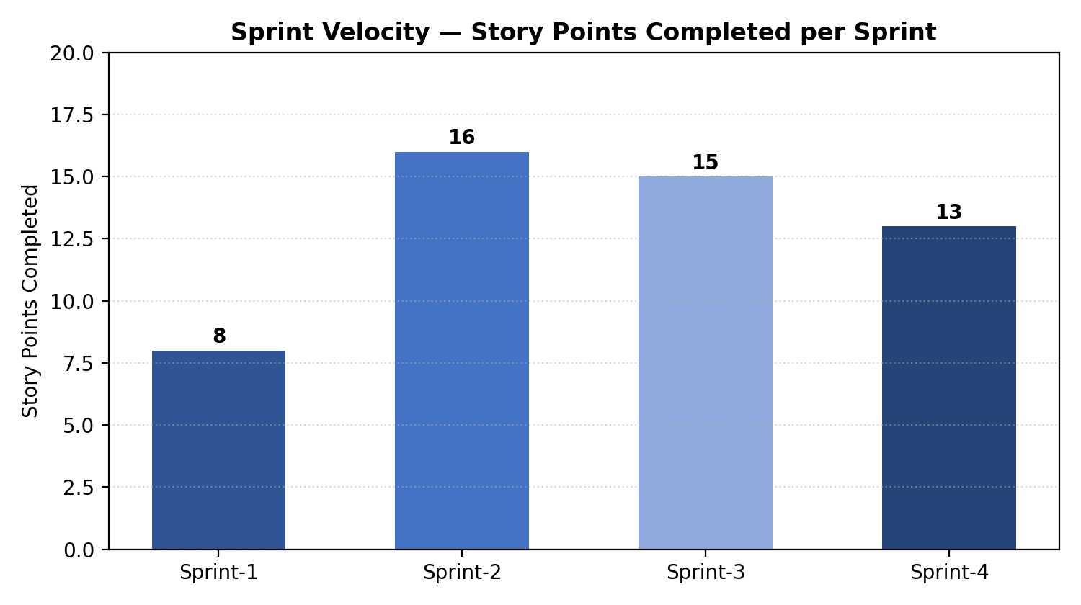

Burndown Chart:
A burn down chart is a graphical representation of work left to do versus time. It is often used in agile software development methodologies such as Scrum. However, burn down charts can be applied to any project containing measurable progress over time.
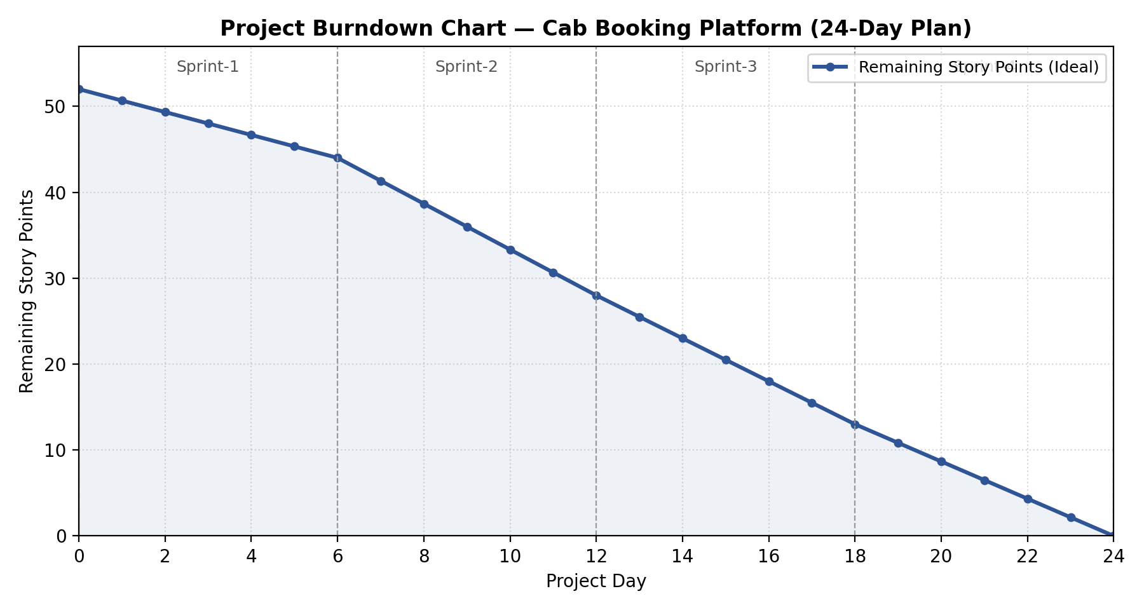
https://www.visual-paradigm.com/scrum/scrum-burndown-chart/
https://www.atlassian.com/agile/tutorials/burndown-charts

Reference:
https://www.atlassian.com/agile/project-management
https://www.atlassian.com/agile/tutorials/how-to-do-scrum-with-jira-software
https://www.atlassian.com/agile/tutorials/epics
https://www.atlassian.com/agile/tutorials/sprints
https://www.atlassian.com/agile/project-management/estimation
https://www.atlassian.com/agile/tutorials/burndown-charts

